Co-Chair  Vernon Sykes, Representative  34th House District | 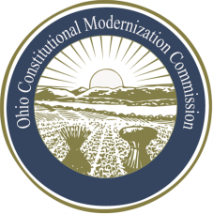 | Co-Chair  William G. Batchelder, Speaker  69th House District
Ohio Constitutional Modernization Commission

Fred Mills, Chair
Thursday, June 13, 2013

Chairman Mills called the meeting of the Ohio Constitutional Modernization Commission to order at 11:30 a.m. A quorum was present.

The Chairman called on members to recommend high priority issues that should be looked at by the subcommittee.

Dean Steinglass gave an overview of several documents he submitted to the committee.

The committee discussed reapportionment and redistricting, as well as term limits as major issues to be addressed

The question was raised as to whether reapportionment was an issue the commission should consider, or if it should be left to the General Assembly for consideration. It was agreed to by the members of the committee that redistricting be a high priority. The committee agreed that the impact of term limits in Ohio be looked at as a high priority as well.

The committee discussed the importance of outreach, expert testimony, and groups that could lead the discussion and provide expertise on issues before the committee.

Meeting times were discussed and the formation of a social committee was suggested so that members of the commission could get to know one another.

With no further business before the committee, Chairman Mills adjourned at approximately 12:30 p.m.

